Trinity United Church
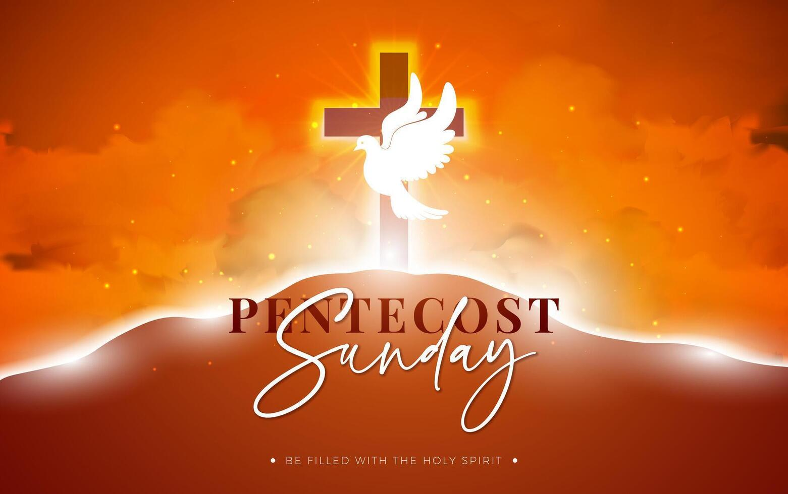
of Christ
Theme – Living Water
May 24, 2026
10:30 am
In-Person Worship FB Live Streaming

The Mission of Trinity United Church of Christ:
We exist to Love people where they are and encourage them to grow in their relationship with Jesus Christ.
Meditation of the Week: “Lord, help me to live this day, quietly, easily. To lean upon Thy great strength, trustfully, restfully. To wait for the unfolding of Thy will, patiently, serenely. To meet others, peacefully, joyously. To face tomorrow, confidently, courageously.” – St. Francis of Assisi
WE GATHER TO PRAISE GOD

Gathering
Feel the Spirit of the community. Worship is a time of both shared community and private conversation with God. Let us all come to this sacred space to enjoy both the loving fellowship of our common faith and the prayerful quiet that will allow us all to draw closer to God.

*Congregation stands when you see an asterisk*

Words of Welcome Rev. Lucy Brady

Joys and Concerns

Prelude: Instrumental Music
*Call to Community MB Brainerd
L: We gather with open hearts, and God meets us in the waiting.
P: The Spirit of God is among us.
L: A breath that stirs, a flame that warms, a voice that calls us together.
P: The Spirit of God is within us.
L: Poured out on all people:
on the hopeful and the weary, the young and the old,
the ones who speak and the ones who listen.
P: We are the Body of Christ.
Come, Holy Spirit, make us one. Set us alight with love.
All: Come, Holy Spirit, Come!

St. Francis Prayer for Peace
by The Burns Sisters. https://youtu.be/CwaaBbq1a00?si=
(https://youtu.be/CwaaBbq1aO0)

*Passing of the Peace

One: The Peace of Christ be always with you.
Many: And also with you

Pass a sign of God’s Peace to one another.

*Opening Hymn: “Sweet, Sweet Spirit” #293 NCH

Growing Disciples
Children are dismissed for Children’s Church
*'Gloria, Gloria (Taizé)'
We Hear God’s Word
First Reading John 20: 19-23 MB Brainerd

*Choral Response “Thy Word” #326 Chalice (sing through 3x)
Second Reading Acts 2:1-21 Rev. Lucy Brady
*Hymn of Preparation: “Spirit of the Living God” 283 NCH

Message “What Does This Mean?” Rev. Lucy Brady

We Respond In Love
Invitation to Generosity

*Choral Response of Thanksgiving Doxology #778

*Blessing Our Gifts

Pastor Prayer
L: Spirit of the living God, you are poured out on all flesh.
You bind us together in one body, and you hear the prayers we carry.
P: Spirit of God, hear our prayer.
L: We pray for the world you love:
for places of conflict and fear, communities caught in violence or in justice, and leaders entrusted with power and responsibility.
Pour out your Spirit of wisdom, restraint, and peace.
P: Spirit of God, hear our prayer.
L: We pray for all who feel overwhelmed or worn down: those carrying heavy burdens, grieving loss, or struggling with illness, anxiety, or isolation. Where hope feels thin, be breath and comfort.
P: Spirit of God, hear our prayer.
L: We pray for those whose voices are often overlooked: the young and the old, the unheard and the unexpected, those on the edges of accepted community. Help us recognize your Spirit speaking through them and learn to listen with humility care.
P: Spirit of God, hear our prayer.
L: We pray for ourselves: for openness to your movement, for courage to follow where you lead, and for trust in one another as we share your work. Make us faithful threads woven into the fabric of your love.
P: Spirit of God, hear our prayer.
Into your keeping , O God, we place all for whom we pray, trusting your Sprit to hold, to heal, and to renew. In the name of Jesus Christ. Amen.
L: We draw our prayers together in the words Jesus taught
All: Our Father

The Lord’s Prayer

Going Forth

Moving Towards Peace on Earth!
The Prayer From Come From Away

Prelude to Service
*Carrying the Light into the World
*Benediction
Go Forth in Peace & Serve!

please note our email address has changed to: officetuccmd@gmail.com

Worship Notes and Resources
Call to Community, prayers of Intersection, and Offering Prayer, were written by The Rev. Jessica Ashcroft-Townsley from Worship Notes from the United Reformed Church UK!
The music in our worship is reproduced via our One License number: A-725765.

Leadership
Katie Penick Pastor
Lucy Brady Guest preacher
Hannah Matthews Director of Music
MB Brainerd Lay Reader
Deb Persinger Worship Committee
Sandy Sanders
Hannah Matthews
MB Brainerd

Strengthen the Church Offering today!

ANNOUNCEMENTS
Worship at Trinity UCC for May 31, 2026
Theme – walking with Purpose
Modern Testimony based on Psalm 8
Modern Testimony based on Genesis 1
Ancient Testimony Matthew 28:16-20
Living in the community of the Trinity
Message Burning Love

Scrip Gift Cards
Please consider taking part in this program.
Orders go in the 1st Sunday of the month.
See Sue Myers for more information, 443-375-6788 or
wsmdem@comcast.net

Submission Dates for Bulletins/Newsletter
Sunday Worship bulletin – Wednesday
June Newsletters – Tuesday, May 26

Meeting Dates by Zoom
Consistory – Wednesday June 3 @ 6 pm
Worship Comm – Third Thursday of each month @ 3:30.

Pastor Katie Sabbath Day will be on Fridays! She will not be available on that day. If there is an emergency text, her
@ 240-418-8028

Budget Information:
Amount needed from all sources each week to meet our budget: $2,436.00.
Giving for Last Week: $ TBA Attendance: 28
Care Fund/Building: $ TBA
We offer various ways to give – cash, checks, or on-line at our website www.trinityuccmanchester.org. Your generous giving allows us to continue our ministries.

Prayers of Thanksgiving and Concerns
Prayers are needed for our World at this difficult time and all those in need.
Prayer requests:
Carolyn Brooks
Annie Durnell
Keith Frecrick, friend of Donna Alban
Joanna Garber
Eva Gebhardt, member of Trinity
Meg Grim, daughter of Pastor Katie
Paul Matthews, Hannah’s father
George Harman, nephew of Karen Price
Jerry Krebs, friend of Deb Persinger
Michael Kulp
Gloria Nethkin
Nancy Nicora, friend of Donna Alban
Ash Van Nuys
Jennifer Penick
Gordon Persinger
George Pietsch
Marc Pulido
Leah, friend of Donna Alban
Beth Robert
Sharon Schneeman, friend of Sandy Sanders
Jean Simmons
Becky & Willy Smith, niece of Karen Price
Dan and Terry Smith
Randy Smith
Kathleen Stevens
Finley Maven Snyder, granddaughter of Karen Price
Gina Tollini
Rev. Debra Wilcox
Keese Williams
Ronnie Williams
Josie Wilson
Nora Renee Winters
Shirley Wood

Please hold the family of Theresa Nethkin in prayer. Gloria’s granddaughter died Monday 18th in the morning.

Pastor Katie will be on vacation
May 22-27.
Rev. Lucy Brady and Rev. Debra Peters
Wilcox are available during emergencies.

Let’s take care of God’s creation.
If you have any extra mugs/cups at home, please bring them to the church kitchen. We will keep these for fellowship to avoid purchasing more disposable items.


Bedtime stories on Wednesday at 7 pm.
DROP IN YOGA
May 30, June 13 Saturdays @ 9 a.m.
See the flyer for more information


Bible Study Thursday’s at 6:30 PM and will be alternate Thursday’s meeting both in person and remotely.
Sunday Morning Bible Study at 9:30 am. We will read Bad Girls of the Bible by Barbara Essex. We will reclaim the stories of women not that different from ourselves: Eve, Lot's wife, Rebekah, Tamar, Potiphar’s wife, Delilah, Jezebel, Job's wife, Gomer, Herodias, the woman caught in adultery, and Sapphira. Please let Pastor Katie know if you are interested.

Trinity U.C.C. Contact Information

Pastor: the Rev. Katie Penick Cell: 240-418-8028
E-mail: pastorkt143@gmail.com
Church Office 410-374-2727
Church e-mail – officetuccmd@gmail.com

Website – www.trinityuccmanchester.org
Facebook - www.facebook.com/ManchesterUCC
President – Sandy Sanders
Vice President – Hannah Matthews
Secretary – Shana Clark
Treasurer – Sue Myers

