Trinity United Church
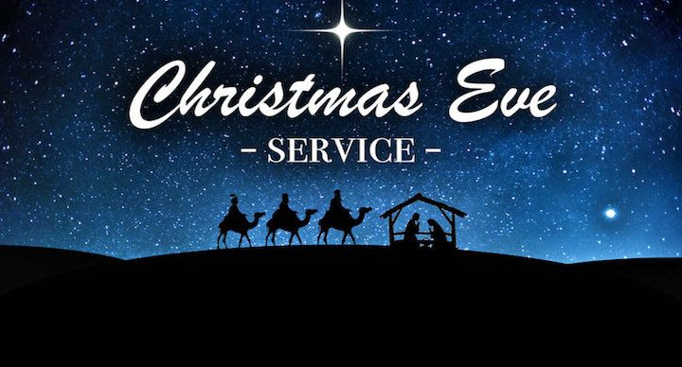
of Christ
Christmas Eve: Light
Sanctuary: Room for All
December 24, 2025
6:30 p.m.

In-Person Worship
FB Live Streaming

The Mission of Trinity United Church of Christ:
We exist to Love people where they are and encourage them to grow in their relationship with Jesus Christ.
Meditation of the Week: “Where there is faith, there is love; Where there is love, there is peace; Where there is peace, there is God; And where there is God; there is no need.” ~Leo Tolstoy~

WE GATHER TO PRAISE GOD

Gathering
Feel the Spirit of the community. Worship is a time of both shared community and private conversation with God. Let us all come to this sacred space to enjoy both the loving fellowship of our common faith and the prayerful quiet that will allow us all to draw closer to God.

Prelude: Festive Prelude & Harmonizations on 'Lo!
He Comes With Clouds Descending' by Paul Fey

Words of Welcome Pastor Katie

Announcements, Joys and Concerns Pastor Katie

*Call to Community (inspired by Isaiah 9) Sue Myers
One: The people who walked in darkness have seen a great light.
Those who lived in a land of deep darkness –
on them light has shined.
Many: We long for a light to guide us.
One: You have multiplied the nation,
you have increased its joy.
Many: We long for God’s joy in our lives.
One: For the yoke of their burden,
and the bar across their shoulders,
the rod of their oppressor,
you have broken as on the day of Midian.
Many: We long for the sanctuary of peace.
One: For a child has been born for us,
a son given to us;
he is named Wonderful Counselor, Mighty God,
Everlasting Father, Prince of Peace.
Many: He is named Emmanuel:
God with us.
In this tiny baby, this vulnerable child,
we find our light, our joy, our comfort.
Joy to the World! The Lord is come!

Prayer of Presence
All: Holy God, on this night we gather with wonder and gratitude. You come to us not in power or splendor, but in humility and love. In the ordinary places of our lives, you make room for your extraordinary presence. Shine your light in us and through us. Fill us with peace, surround us with joy, and send us out with your love to share the good news: Christ is born! It is in the name of the One who is the Light of the World that we pray. Amen.
*Passing of the Peace
One: The Peace of Christ be always with you.
Many: And also with you
Pass a sign of God’s Peace to one another.

*Opening Hymn: “O Come, All Ye Faithful” #103 LC
(verses 1, 3 & 4)

Lighting the Candles of Blessing ~
The Clark Calabrese Family
One: Tonight, we light the Christ candle. For when there was no room, God made room, in a manger, in a stable, in the heart of the world.
All: in the light shines in the darkness and the darkness cannot overcome it.
One: As we light this candle, we proclaim: Christ is born!
All: Alleluia! Glory to God in the highest!
(Light the four candles)

*Advent Choral Response: “Sanctuary” #482
(Worship & Rejoice)
(sing through 2x)
~silence is kept~

Celebrating God’s Presence
Sanctuary at the Manger: Mary

Sylvia Calabrese
First Lesson Luke 1:26-35 The Story of Mary

*Hymn: “Angels We Have Heard On High” #113 LC

Scripture Response Isaiah 7:14
God will give you a sign.
Behold, a virgin shall conceive and bear a son.
And they shall name him Emmanuel,
Which means, God is with us.
Prayer
God of Love, when you chose Mary to be the mother of your Son, you showed your love for the poor and lowly. Grant us grace to receive your Word, and so to be made one with Jesus Christ, who lives and reigns with you and the Holy Spirit, one God, now and forever. Amen.
Sanctuary at the Manger: Joseph
Ashby Haines
Second Lesson Matthew 1:18-21 The Story of Joseph

*Hymn: “O Little Town of Bethlehem” #121 LC
(verses 1, 2, & 4)
Scripture Response Isaiah 11:1-2
A shoot shall come out from the stump of Jesse.
And a branch shall grow out of his roots.
The spirit of the Lord shall rest on him.
The spirit of wisdom and understanding.
The spirit of counsel and might.
The spirit of knowledge and the fear of the Lord.

Prayer
O God, when you chose Joseph to raise your Son, you reached back into the ancient roots of faith and hope found in the family of David. Give us grace to live lives of faith in the most unexpected places; through Jesus Christ, who lives and reigns with you and the Holy Spirit, one God, now and forever. Amen
Sanctuary at the Manger: The Star
Cindy Piazza
Third Lesson Matthew 2:1-2, 7-10 The Story of the Star

*Hymn: “It Came upon the Midnight Clear” #131 NCH
Scripture Response Isaiah 60:1-2
Arise, shine, for your light has come.
And the glory of the Lord has risen upon you.
For darkness shall cover the earth,
And thick darkness the peoples.
But the Lord will arise upon you,
And his glory will appear over you.

Prayer
O God, by the light of a star you revealed Christ to all people. Lead us, who know you by faith, to your presence, where we may see your glory face to face; through Jesus Christ, who lives and reigns with you and the Holy Spirit, one God, now and forever. Amen.
Sanctuary at the Manger: The Angels
Ben Hamilton
Fourth Lesson Luke 2:8-14 The Story of the Angels
*Hymn: “Hark! the Herald Angels Sing” #106 LC
Scripture Response Isaiah 10:9
Get you up to a high mountain, O Zion, herald of good tidings.
Lift up your voice with strength, O Jerusalem, herald of good tidings.
Lift it up, do not fear.
Say to the cities of Judah, "Here is your God!"

Prayer
Joyful God, in the song of the angels you celebrated the light of the world found in a new born baby. On this Christmas Eve, may our hearts sing with joy for the precious gift given: through Jesus Christ, who lives and reigns with you and the Holy Spirit, one God, now and forever. Amen.
Sanctuary at the Manger: the Christ Child
Maddie Hudgins
Fifth Lesson Luke 2:1-7 The Story of Jesus’ Birth

*Hymn: “Joy to the World” #120 LC
Blessing of the Christ Child
O God, Source of all Blessings, from the very beginning of creation you have shown us your love. When your people lost hope, you showed us how extravagant your love is through the birth of Jesus Christ, who brings joy and peace, justice, mercy, and love. Bless all who look upon this manger; may it remind us of the humble birth of Jesus and raise our thoughts to the one who is God-with-us and Savior of all, and who lives and reigns forever and ever. Amen.
Message
Invitation to Generosity

*Choral Response “In the Bleak Midwinter”
#128 NCH (verse 4)

*Blessing Our Gifts
All: Holy God, bless these gifts of love. May they shine with Christ’s light, bringing comfort and joy to all who are in need. Let them build sanctuaries of peace where there is fear, and kindle joy where hearts feel weary. It is in the name of the One who is the Light of the World, we pray. Amen.
Sacrament of Communion

Special Music- At This Table by Idina Menzel
Sung by Marge Bailey, MB Brainerd,
Shana Clark, & Cindy Piazza

Invitation
One: God be with you
All: And also with you.
One: Let us open our hearts to the Spirit of Christ, born so many years ago, and who continues to live here tonight.
All: We thank God with joy
Thanksgiving
One: God of humble births and the stars in the heavens, we thank You for Your enduring love for all creation. We thank You for those who can see You and make connections that lead toward meaning. We thank You for those who are wise—who will journey out to strange lands and unknown territories in search for truth or to bring justice. We thank You for Your way of breathing life into us, and of helping us to take deep breaths when we need them.
All: God of love, creativity, novelty, joy, meaning, peace and hope, in spite of all the challenges on earth and in our personal lives, we give thanks for Your persistence throughout the universe.
One: We rejoice in Your Word through Jesus the Christ, who was born humbly, who communed with those others called outcast, who lived a complex life that sought justice, who died unfairly, and whose Spirit lives among us still.
Remembrance
One: Remembering Your boundless love, we offer our praise and proclaim our faith:
All: Christ was born. Christ lived and died. Christ comes again and again into our lives.
One: God, we know that Your Spirit is poured on us and on these elements of bread and juice, and we pray that Your love, peace and justice in the world may be born through us.
All: All praise to You, rejoicing in the Spirit of Jesus Christ, who lives among us, and the Holy Spirit, who binds us together in love. Amen.
Breaking the Bread and Pouring the Cup
Sharing the Meal
Instrumental music: Winter Melody by Paul Fey

The Lord’s Prayer

Moving Towards Peace on Earth!

Sharing the Light
*Closing Hymn: “Silent Night! Holy Night!” #117 LC

*A Christmas Eve Benediction
One: Tonight, as we celebrate God is with us in the birth of Jesus, let us continue to live lives of hope, peace, joy, and love.
Share God’s love with the shepherds you meet on the hillside.
Let the communion of the Holy Spirit fill your heart with glad tidings like the angels.
May the Prince of Peace born again tonight, and live in your heart to comfort and challenge you as you seek to live as one of his disciples.
All: Amen.

Prelude to Service: Instrumental music
*Carrying the Light into the World
Go Forth in Peace & Serve!

Worship Notes and Resources
Adapted from Rev. Eliza Buchakjian-Tweedy, Pastor at First Church Congregational in Rochester, NH. https://breakthroughseries.org/series/sanctuary, https://processandfaith.org/holy-communion-service-for-christmas-eve/, benedictions for Advent — LiturgyLink,
The music in our worship is reproduced via our One License number: A-725765.

The flowers on the altar are sponsored by Gloria Nethkin in memory of her husband, Vernon and her children, Brian and Debbie.

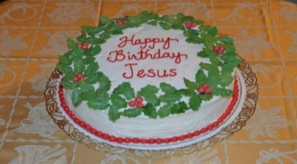

“Please join us following worship tonight downstairs. For fellowship and to celebrate the birth of Jesus”

Leadership
Katie Penick Pastor
Hannah Matthews Director of Music
Sue Myers Lay Reader
Deb Persinger Worship Committee
Sandy Sanders
Hannah Matthews
MB Brainerd

Trinity U.C.C. Contact Information

Pastor: the Rev. Katie Penick Cell: 240-418-8028
E-mail: pastorkt143@gmail.com
Church Office 410-374-2727
Church e-mail – trinityuccmanchester@comcast.net

Website – www.trinityuccmanchester.org
Facebook - www.facebook.com/ManchesterUCC
President – Sandy Sanders
Vice President – Hannah Matthews
Secretary – Shana Clark
Treasurer – Sue Myers



