If you are looking for warm people who will love you just as you are, consider worshiping with us. Trinity United Church of Christ has been welcoming seekers for over 250 years, and we invite you to be part of our long tradition of welcoming! Worship at Trinity is participative, held in a beautiful traditional sanctuary with inspiring sermon series and a diverse musical offering from our choir and congregation.

Our faith is 2,000 years old. Our thinking is not. We believe in God’s continuing testament. This is why we are committed to hearing God’s ancient story anew and afresh in our lives and in the world today. We try to remain attentive to God’s creative movement in the world. Religion and science are not mutually exclusive, and your head and heart are both welcomed into our places of worship. We prepare our members and leaders to be engaged in ministry in the present and future church, and we embrace all kinds of communities and new modes of thinking. Why? Because God is still speaking.

Beyond Our Walls. Trinity is committed to the community beyond our walls in Manchester, or even in Carroll County. We are involved in a variety of outreach efforts in the name of Christ. Food Bags for Backpacks: Food items are collected monthly during the school year for Manchester Elementary School for students who receive Free/Reduced meals.

Cold Weather Shelter: We cook for the residents of and staff the cold weather shelter in Westminster, MD. We began this effort in two years ago by working at the shelter one night and have expanded to working two nights during the winter months. Prayer Shawls are made and blessed monthly for those needing a spiritual touch.

Caring Committee: The caring committee responds to emergency requests from the community. We partner with Human Services Programs and NESAP to guide individuals to resources available in the community.

Trinity United Church of Christ
3229 York St., Manchester, MD 21102
e-mail for more information: pastortucc@comcast.net
e-mail church: trinityuccmanchester@comcast.net
410-374-2727 (church office)
www.trinityuccmanchester.org, Facebook
Rev. Dr. Gerry Hanberry, Interim Pastor
Trinity United Church of Christ
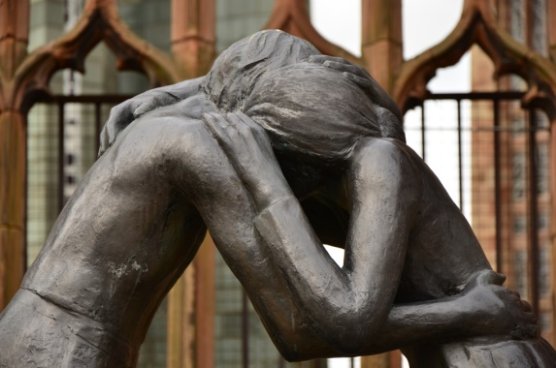

“ Reconciliation” in St. Michael’s Cathedral, Coventry, England

July 14, 21, 28, August 4, & 11, 2019

The Ministry of Reconciliation –
Truth, Forgiveness and Reconciliation

“All this is from God, who reconciled
us to God’s self through Christ and
gave us the ministry of reconciliation.”
(2 Corinthians 5:18)

Website – www.trinityuccmanchester.org

The Ministry of Reconciliation –
Truth, Forgiveness and Reconciliation

One of God’s gifts to us, even though we are sometimes unforgiving and hurtful people, is the gift of reconciliation. With reconciliation come the parallel gifts of truth-told-to-love and forgiveness that brings healing. In 2 Corinthians 5, Paul is saying, as Christians or people of faith, we do not do any or all of this by ourselves.

Achieving forgiveness in our relationships is both “communal” work and relational. We are not the sole processors of the whole truth. Mpho Tutu, daughter of Bishop Desmond Tutu, says “whether one offers or receives forgiveness, neither has the whole truth; absolute truth rests with God.” Tutu’s book, The Book of Forgiving (published by Harper One), will be one contemporary source for this series.

What then is reconciliation? It is the “restoration of right relationships,” which is the outcome of the work of forgiveness and reconciliation. This work requires the truth to be told and to be heard — all in the name of love and grace and compassion for each other. This ministry of making relationships right will be the focus of our worship in July and the first part of August. The texts from Paul’s letter to the church at Corinth (2 Corinthians 5:17-21), selected lessons from the gospels, and from what could be called the “continuing texts” (contemporary readings and poetry) of Henri Nouwen and others will serve as the basis for this worship series.

For more information contact Pastor Gerry Hanberry at 301-788-6546 or email at pastortucc@comcast.net

July 14 — The Ministry of Reconciliation: Truth
- Readings: Psalms 85, 2 Corinthians 5:17-21, John 3:17-21, John 8:31-38
- Pastor Hanberry’s Sermon: “Telling the Truth in Love”

July 21 — The Ministry of Reconciliation:
Telling Truth to Power
- Reading: Matthew 10:40-42
- Pastor Hanberry’s Sermon: “A Table of Reconciliation”

July 28 — The Ministry of Reconciliation: Forgiveness,
Part 1
- Readings: Genesis 33:11, Psalms 32, Ephesians 4:25-5:2, Luke 6:27-42
- Pastor Hanberry’s Sermon: “The Forgiveness Project”

Aug 4 — The Ministry of Reconciliation: Forgiveness,
Part 2
- Readings: Romans 13:8-14, Matthew 18:15-20, 21-22,
& 23-35
- Pastor Hanberry’s Sermon: “The Forgiveness Process - A Way of Life”

Aug 11 — The Ministry of Reconciliation:
Reconciliation Completed
- Readings: Joel 2:23-27, Psalms 30, Matthew 5:21-26
- Pastor Hanberry’s Sermon: “Right Relationships: The Future Secured”

____________________
VBS at Trinity UCC
July 21 – 26
6:30 – 8:45 pm
Register online at our website

